Creative Writing Workshops
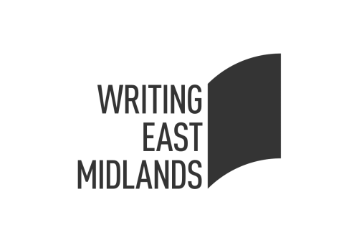& City of Sanctuary
Every Tuesday 11.00am – 12.30pm
at Derby Refugee Advice Centre
Starting Tuesday, 4th October, 2016 - Tuesday, 20th December, 2016
Explore ideas and expand your talents with creative writing. Learn from professional writers and gain confidence. No experience necessary. All aspiring writers are welcome.
Sharpen the quill, summon the muse and draft a masterpiece

